Table 5: IT-Architecture, Workflow and Map Viewer

Sharing information on adaptation to climate change
URL: http://climate-adapt.eea.europa.eu/share-your-info

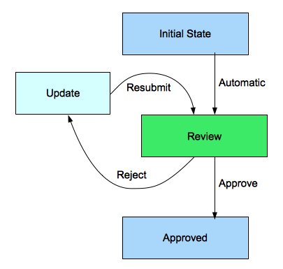
Visualisation of climate indicators and data
URL: http://climate-adapt.eea.europa.eu/tools/map-viewer
